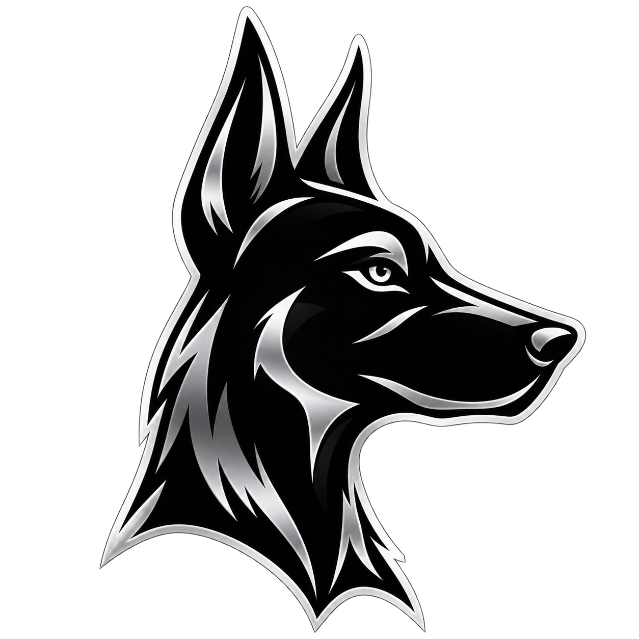
WATCH DOG EM

DDC & Meter
Configuration Guide
  - A practical administrator procedure for real Modbus RTU commissioning
Purpose | Add a new DDC/controller, create up to 45 meter channels, assign UMEME or Generator, and confirm live operation.
Audience | Watch Dog EM Administrators and electrical/controls commissioning personnel.
Applies to | Watch Dog EM local installation using Windows USB-to-RS-485 and Modbus RTU.
QUICK OUTCOME
When this procedure is complete, the meter appears on the Dashboard and automatically appears on the UMEME or Generator page selected during channel creation.

1. Before You Start
SAFETY RS-485 wiring and controller configuration must be performed by qualified personnel. Isolate power where required and follow the DDC and meter manufacturer instructions.

- Sign in with an Administrator account. Use Administrator login; Bootstrap is only for the first Administrator on a new installation.
- Create the Shop first: Shops > Add shop. A meter channel must be assigned to a shop.
- Confirm the DDC is programmed as a Modbus RTU slave and exposes the energy value in holding registers.
- Connect the USB-to-RS-485 adapter and confirm its Windows COM number in Device Manager.
- Record the DDC slave address, baud rate, parity, data bits, stop bits, register address, data type, word order, and scaling factor.

Important Port Difference
Windows COM port | The PC adapter port shown in Device Manager, for example COM1. Enter this in Watch Dog EM.
DDC physical port | The controller terminal/port, for example COM2 RS-485. Configure this inside the DDC only.
Rule | PC COM1 may communicate with DDC COM2. These names do not need to match; the RS-485 wires connect the two devices.

2. Configure the DDC for Modbus RTU
- Set the DDC communication protocol to Modbus RTU, not Modbus ASCII.
- Configure the DDC RS-485 serial settings. The DDC and Watch Dog EM values must match exactly.
- Set a unique Modbus slave address for the DDC, normally 1 unless the site design specifies another address.
- Move each meter’s accumulated energy value into consecutive DDC registers according to the approved register map.
- Download the program to the DDC and place it in RUN mode.
Setting | Example | Must match
Protocol | Modbus RTU | Application communication type
Baud / frame | 9600, Even, 8 data bits, 1 stop bit | Application serial settings
Slave address | 1 | Application slave address
Function | 03 - Read Holding Registers | Watch Dog EM physical read
First value | D100 mapped as register 4196 | Configured meter register
REGISTER NOTE The current application guide uses register 4196 for D100. Confirm this against the actual Delta DDC register map. Do not guess the address.

3. Add the Controller in Watch Dog EM
- Open Administrator login and enter the Administrator username and password.
- Open Controller setup from the top navigation.
- Click + Add controller.
- Complete the controller form using the verified site settings.
Application field | Example | What to enter
Name | DDC-01 | A clear unique controller name.
MDB panel | MDB-METERS-01 | Panel or location identifier.
Communication type | Modbus RTU | Current supported physical protocol.
Enabled | Selected | Allows background polling.
Windows USB/RS-485 port | COM1 | The Windows port, not the DDC’s COM2 label.
Baud / parity / data / stop | 9600 / Even / 8 / 1 | Must match the DDC exactly.
Slave address | 1 | Must match the DDC slave address.
Polling / timeout / retry | 5 s / 1000 ms / 2 | Starting values; adjust only when needed.
- Select the real-mode confirmation only after the wiring, DDC program, and register map are verified.
- Click Save controller configuration. The controller must be saved before meter channels can be added.

4. Create Meter Channels
- Return to Controller setup and click 45 channels beside the required controller.
- In Bulk-create meter register channels, enter the meter name prefix and physical serial number.
- Select Power source: UMEME for government utility supply, or Generator for generator supply.
- Enter the number of channels. Use 1 for one meter; each DDC supports a maximum of 45 meters.
- Enter the first register address, register stride, data type, word order, and scaling factor from the approved DDC register map.
- Select the correct shop assignment, then click Generate channels.
POWER SOURCE This dropdown is on the controller’s 45 channels page. The selection automatically controls whether the meter appears on the UMEME page or Generator page.

Register Example
Meter | Register | Stride | Data type | Scale
Meter-01 | 4196 | 2 | UInt32 | 0.01
Meter-02 | 4198 | 2 | UInt32 | 0.01
Meter-03 | 4200 | 2 | UInt32 | 0.01
CAUTION The example is valid only if the DDC truly exposes consecutive UInt32 values with a stride of two registers and the selected word order. Confirm before saving.

5. Commission Each Meter
- In the Register matrix, click Edit beside the generated meter.
- Confirm the meter name, physical serial number, controller, power source, register address, and shop assignment.
- Confirm data type, word order, scaling factor, pulse constant, and CT settings.
- Select Commissioned and active only when the physical meter and its DDC register are ready.
- Click Save meter channel.

6. Test Communication
- Open Controller setup and click Edit / test beside the controller.
- Confirm the Windows COM port is not being used by another Modbus tool.
- Click Test communication. Watch Dog EM opens the serial port and performs a real Modbus RTU Function 03 read of the first assigned meter channel.
- Review the result banner. A successful read confirms the serial link, slave response, and first register request.

7. Verify the Result
Where to check | Expected result
Dashboard | The meter appears under Live meter status after the meter channel exists. Active meters are polled by the background service.
UMEME page | Shows only meters whose Power source is UMEME.
Generator page | Shows only meters whose Power source is Generator.
Controller channels | Shows the register, data type, word order, scale, power source, and Active/Not commissioned status.
Last reading | Updates after a valid poll. A meter can appear before it has received its first live reading.

8. Troubleshooting Checklist
- Meter missing from Dashboard: verify that a meter channel was created. Creating only a Shop or Controller does not create a meter.
- Meter on wrong source page: edit the meter channel and correct Power source to UMEME or Generator.
- No communication: confirm the Windows COM port shown in Device Manager; do not enter the DDC’s internal COM label.
- No response: verify Modbus RTU, slave address, baud rate, parity, data bits, stop bits, RS-485 polarity, and common reference/ground requirements.
- Connected but wrong value: verify register numbering, zero/one-based offset, UInt32 word order, scaling factor, pulse constant, and CT ratio handling.
- COM port busy: close PLC programming software, Modbus scanners, and other applications using the adapter.
- Value does not change: confirm the DDC value changes online, the correct register is mapped, and the browser/background polling has refreshed.

9. Final Commissioning Record
Complete this checklist before handing the meter to billing operations.
☐ Shop created and verified
☐ DDC/controller saved and enabled
☐ Windows COM port confirmed
☐ Modbus RTU parameters match
☐ Slave address verified
☐ Meter channel generated
☐ UMEME or Generator selected
☐ Physical serial number entered
☐ Register map confirmed
☐ Meter commissioned and active
☐ Communication test successful
☐ Dashboard reading verified
☐ Tariff assigned to this meter

Site Record
Shop / tenant | ____________________________________________
Controller name | ____________________________________________
Windows COM port | ____________________________________________
DDC slave address | ____________________________________________
Meter name / serial | ____________________________________________
Power source | ____________________________________________
Register / type / scale | ____________________________________________
SUPPORT NOTE Keep the approved DDC program, register map, serial settings, and a database backup with the commissioning record.

